Press release

Stuttgart/Germany, April 20, 2022
Lightest e-bike drive system on the market
- New X20 drive from MAHLE Smartbike Systems sets new benchmark for power-to-weight ratio
- System weight: 3.2 kilograms
- Invisible integration into the frame and hub
- Artificial intelligence offers a customizable cycling experience
- Market launch on April 20, 2022

With its new X20 model, MAHLE Smartbike Systems has launched the lightest e-bike drive system on the market, weighing in at just 3.2 kilograms—including the battery. The Stuttgart-based automotive supplier’s e-bike business segment has thus set a new industry benchmark for the power-to-weight ratio of e-bike drives. The X20 also has an aesthetic advantage, because it is concealed within the bike’s frame and hub. In addition, artificial intelligence delivers a customizable cycling experience that is perfectly tailored to the rider. The new drive system is available as of April 20, 2022.
“With the X20, we are starting a completely new chapter by combining weight advantage, aesthetics, and customization in an unprecedented drive solution,” said Jochen Sommer, head of MAHLE Smartbike Systems.
“The X20 gives riders the exact support they need as individuals, providing the ultimate cycling experience,” added Marco de la Serna, head of Strategy and Business Development at MAHLE Smartbike Systems.
The MAHLE X20’s motor weighs just 1.4 kilograms. It is perfectly tailored to the design of gravel bikes and urban e-bikes and can be disconnected from the system with just one click. The rear wheel can thus be easily removed without technical expertise or special tools. The hub motor delivers 23 newton meters directly to the wheel—a power output comparable with that of a mid-drive motor with 55 newton meters of torque.
In addition, the X20 has a sophisticated sensor package that measures acceleration, speed, torque, temperature, and pedaling rate. It also uses artificial intelligence to continuously adapt the drive to the person in the saddle. The X20 thus offers a perfectly tailored cycling experience—even when riders or training conditions change. Further impressive features of the drive system are its absolutely natural pedal feel, which is similar to that of a conventional high-performance sports bike, and the noise-free support it offers the user. Communication between cyclist and vehicle takes place via a modern HMI with haptic feedback.
The two available batteries, iX250 and iX350, deliver sufficient energy in any situation. They can be quickly charged using the MAHLE Active Charger—easily reaching 80 percent charge within one hour. If more cruising range is needed, an optional range extender can be added. The range extender almost doubles the cruising range, weighs just one kilogram, and is shaped like a water bottle, which can be attached to the frame. By means of a docking station, this additional battery can also be used as a power bank to charge a laptop or mobile phones while on the go.
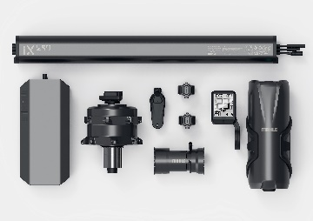
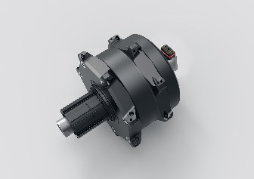
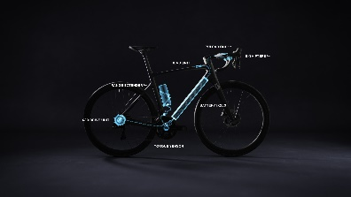
AI on board: the X20 adapts to the rider using artificial intelligence.
Weighing just 3.2 kilograms, the MAHLE X20 is the lightest drive system on the market.
Aesthetically appealing: the battery and drive are hidden within the frame.

Contacts in MAHLE Corporate Communications:
Ruben Danisch
Head of Corporate and Product Communications
Phone: +49 711 501-12199
E-mail: ruben.danisch@mahle.com

Christopher Rimmele
Product, Technology, and Aftermarket Communications Spokesman
Phone: +49 711 501-12374
E-mail: christopher.rimmele@mahle.com

About MAHLE
MAHLE is a leading international development partner and supplier to the automotive industry. The technology group is now broadly positioned in the areas of powertrain technology and thermal management with a clear focus on future topics relating to mobility. As part of its dual strategy, MAHLE is working both on the intelligent combustion engine for the use of hydrogen and other nonfossil fuels and on technologies that will help the fuel cell and e-mobility achieve broad acceptance in the markets. The product portfolio of the company, which was founded in 1920, addresses all the crucial aspects of the powertrain and air conditioning technology. Half of all vehicles in the world now contain MAHLE components. #weshapefuturemobility
In 2020, MAHLE generated sales of approximately EUR 9.8 billion and is represented in over 30 countries with more than 72,000 employees in 160 production locations and 12 major research and development centers. (Last revised: 2020-12-31)

